Course Name: | Web Development Laboratory | Semester: | V
Date of Performance: | 19 /08 /2026 | DIV/ Batch No: | A2
Student Name: | Abhishek D. Khedekar | Roll No: | 16014024029

Experiment No: 4
Title To design and develop a responsive, component-rich Web Portal using the Bootstrap
framework, incorporating grids, layouts, navigation, alerts, input groups, pagination, and custom styled components.

Aim and Objective of the Experiment:
- To develop JavaScript applications using arrays, operators, functions, events, DOM manipulation, and form validation to solve practical problems.
- To implement asynchronous programming using callbacks, nested callbacks, Promises, Promise chaining, and async/await for sequential application-based operations.
- To handle user interactions and errors effectively using event handling, input validation, try-catch, and appropriate asynchronous error-handling techniques.

COs to be achieved:
CO2:

Problem Statement:
Task1: Create an array of product prices. Calculate the total bill, apply a discount if the total exceeds a specified amount, and display the final amount.

Task 2: Create buttons such as Submit, Cancel, and Reset. When a button is clicked, change its own text using the this keyword.

Task 3: Create a text box where the number of characters entered is displayed dynamically whenever the user types.

Task 4: Create a registration form with name, mobile number, email, password, confirm password, and gender. Validate all fields before submission.

Task 5: Simulate the following sequence using nested callbacks:
Select Food → Confirm Order → Prepare Food → Assign Delivery Partner → Deliver Food.
Display an appropriate message after each operation.

Task 6: Create a program that simulates:
Select Product → Check Availability → Add to Cart → Make Payment → Generate Order Confirmation.
Each operation should return a Promise and be executed using promise chaining.

Task 7: Develop a program to simulate:
Select Movie → Check Seat Availability → Reserve Seat → Make Payment → Generate Ticket.
Use async/await and try...catch for error handling.

HTML tags used:
<!DOCTYPE html>, <html>, <head>, <meta>, <title>, <link>, <body>, <header>, <nav>, <a>, <button>, <span>, <div>, <ul>, <li>, <main>, <h4>, <p>, <code>, <textarea>, <strong>, <form>, <label>, <input>, <pre>, <footer>, <small>, <script>

Code:
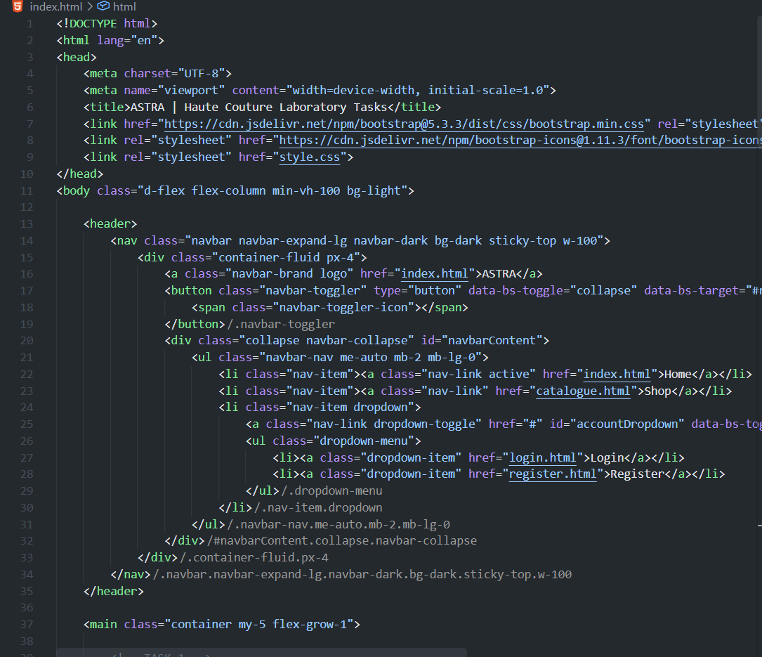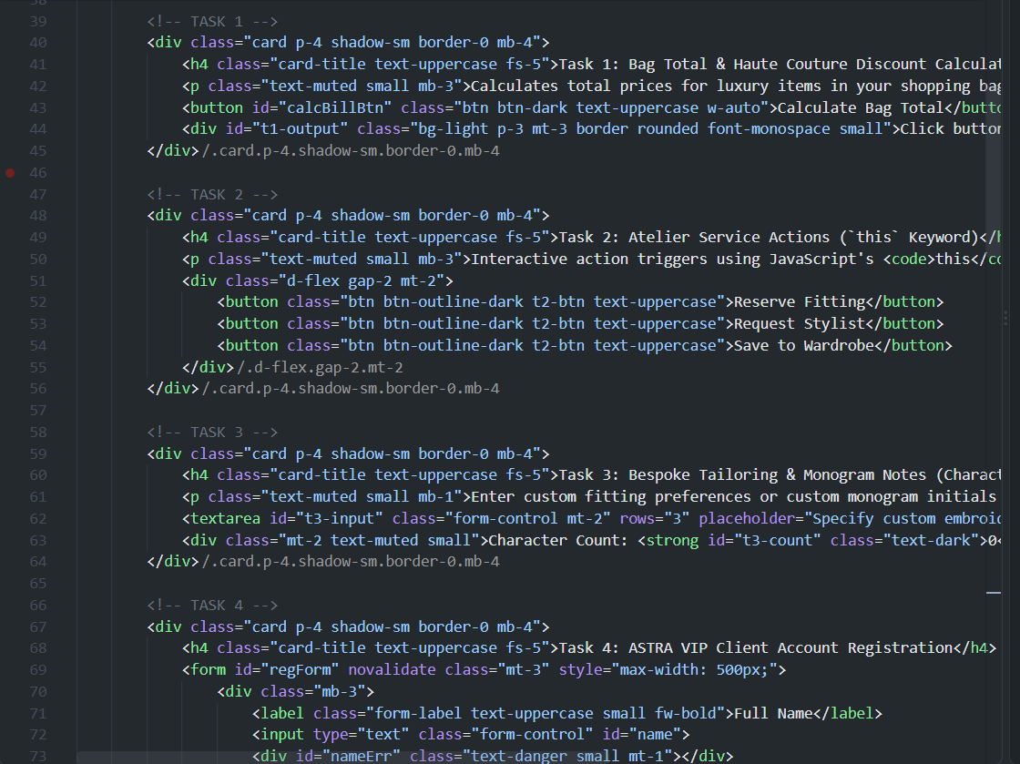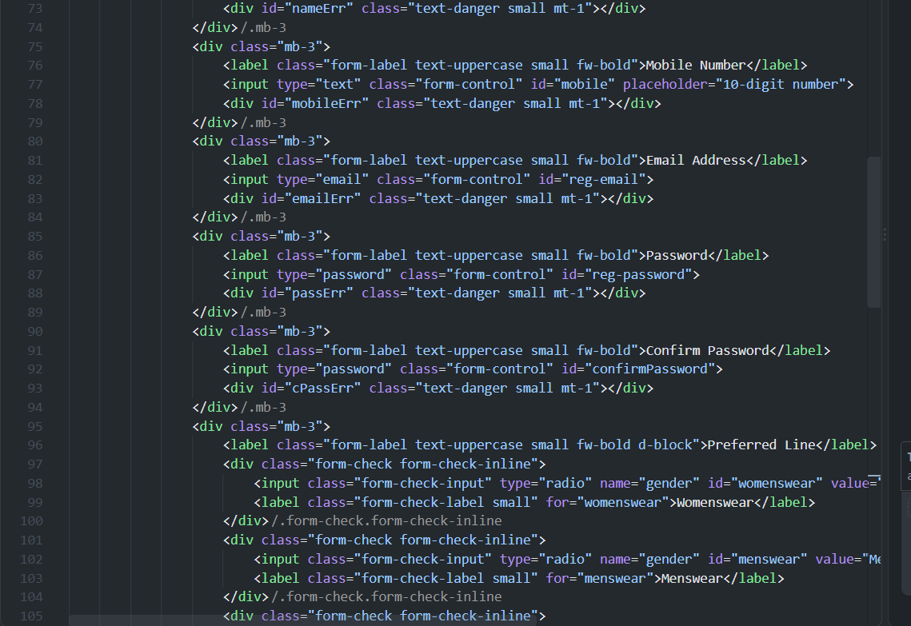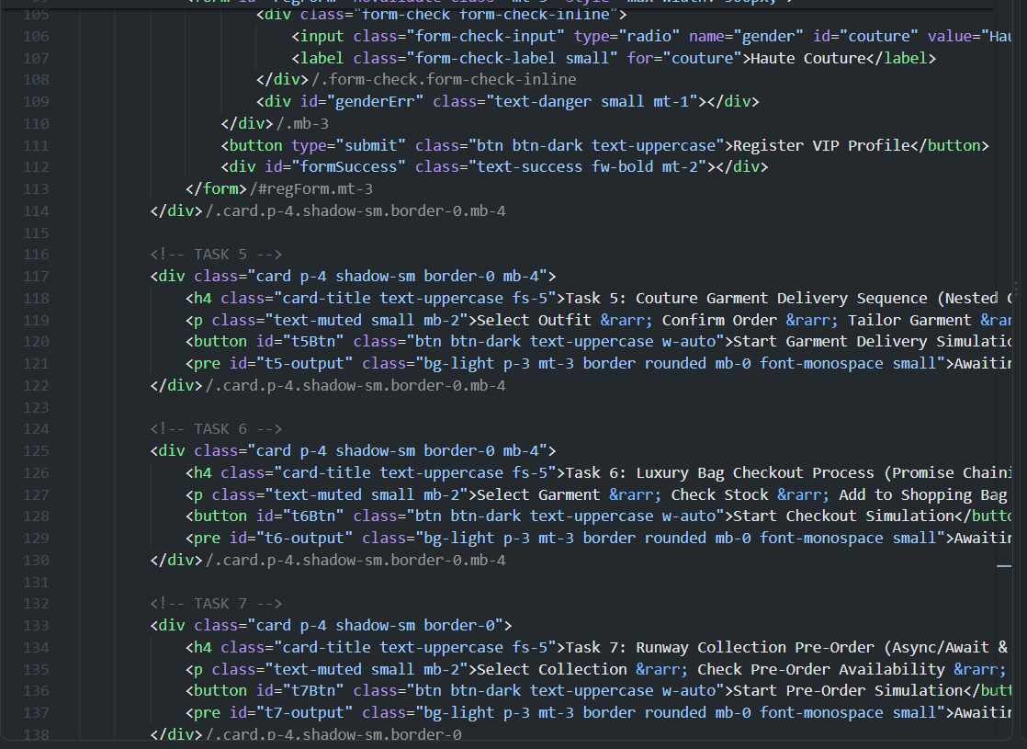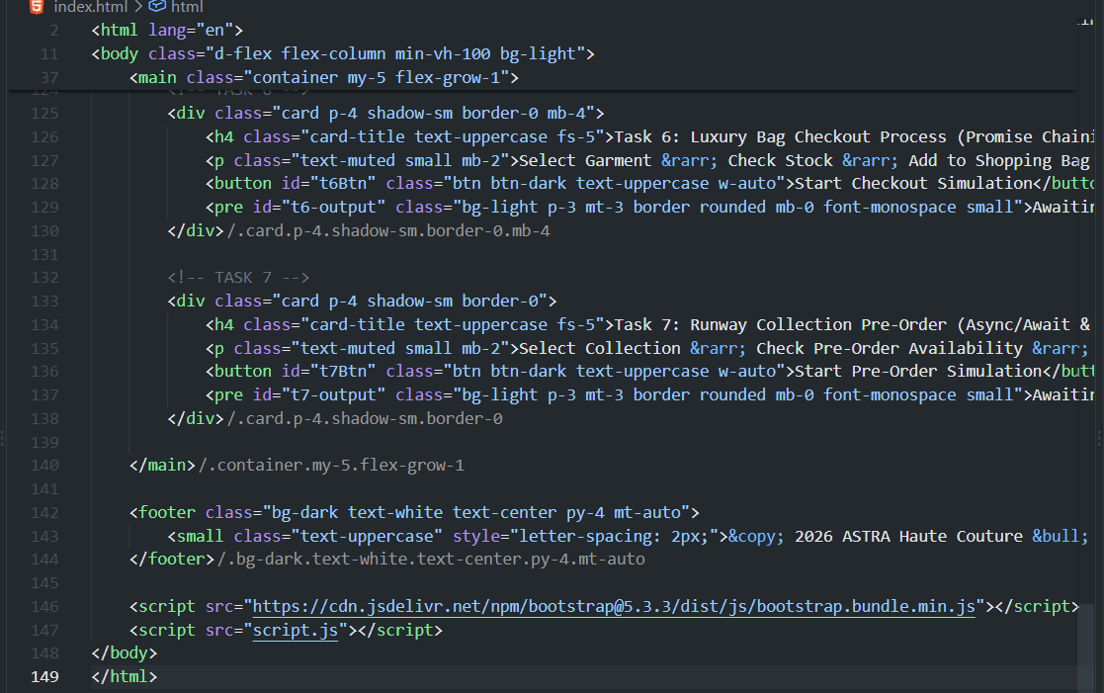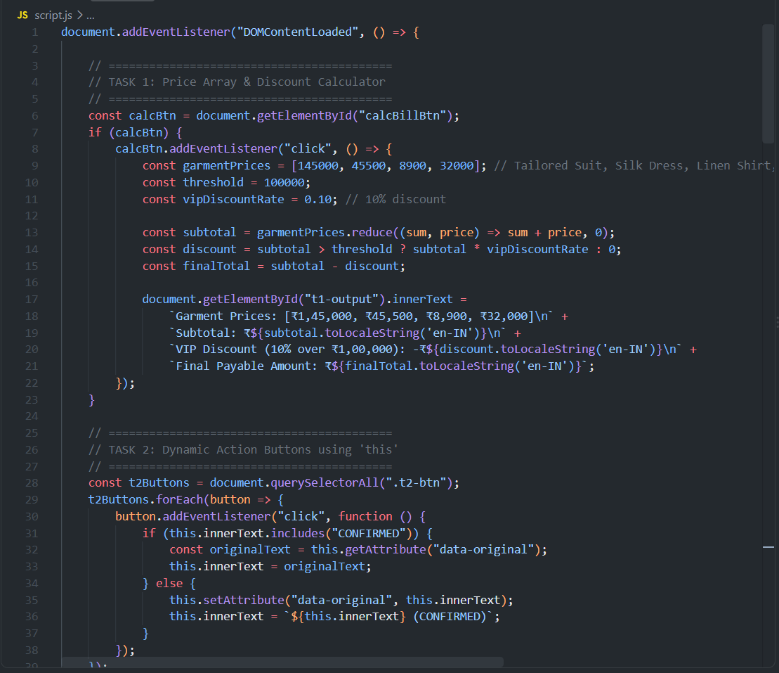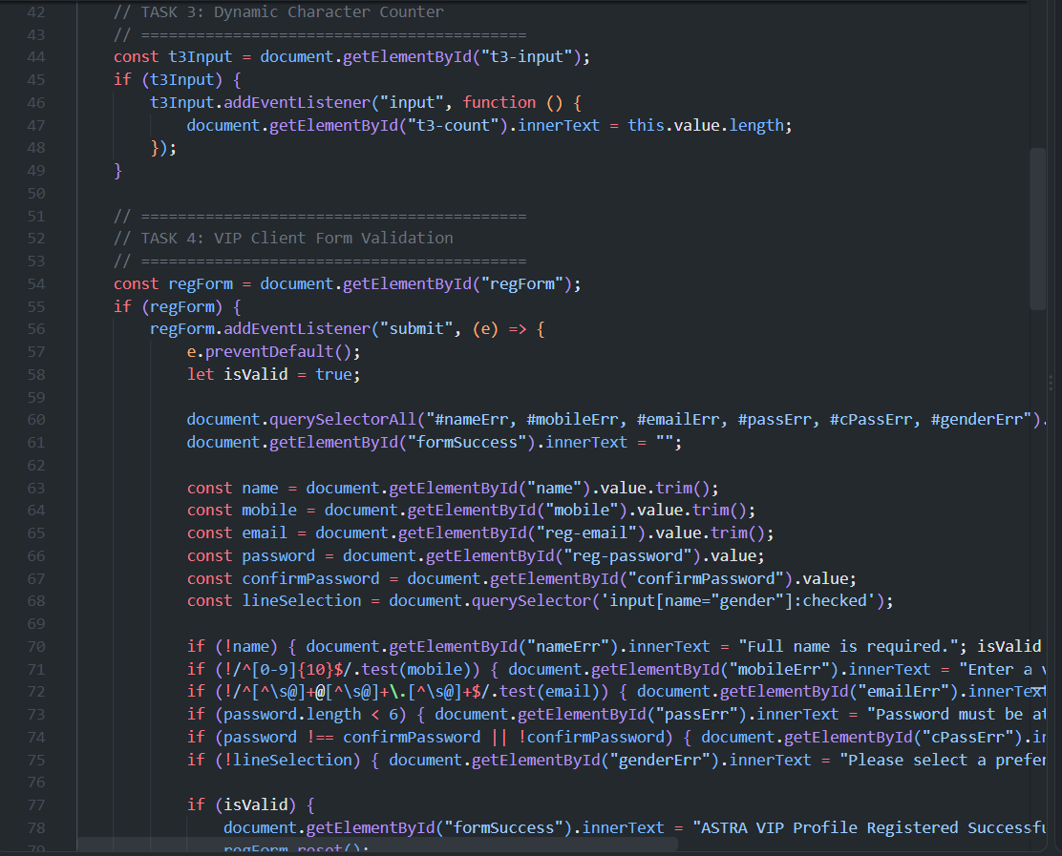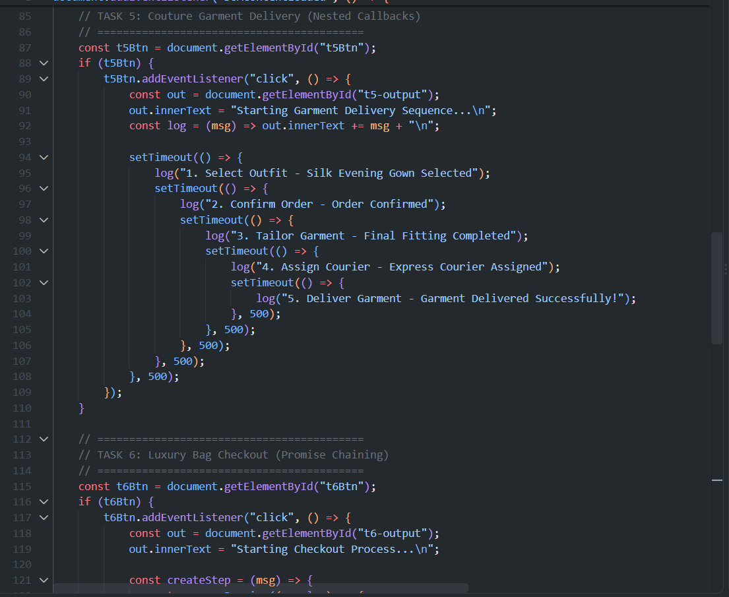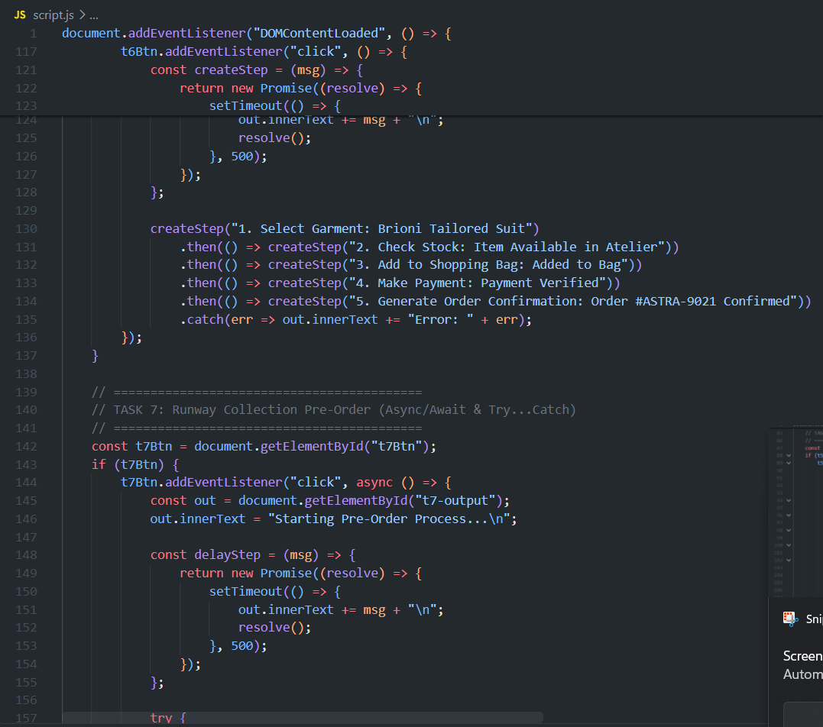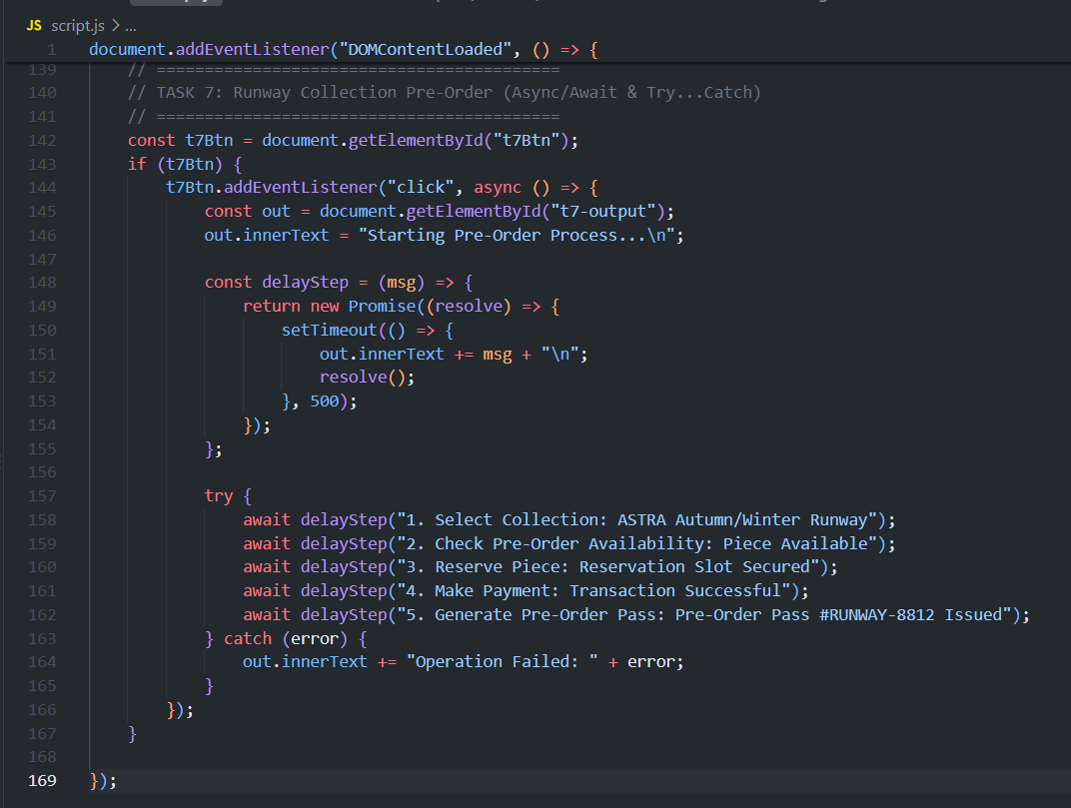

Stepwise-Procedure / Algorithm:
1. Build Layout Structure: Create index.html using Bootstrap 5 CDN links to structure responsive containers, card components, form controls, and navigation bars.
2. Implement DOM Manipulation & UI Controls: Write JavaScript listeners in script.js to calculate item totals with VIP discounts, update character counters dynamically on text input, and toggle button text using the this keyword context.
3. Add Form Validation Logic: Implement client-side input validation for the registration form using regular expressions to check email formats, 10-digit mobile numbers, and matching passwords.
4. Implement Asynchronous Workflows:
- Nested Callbacks: Structure chained setTimeout functions to simulate the sequential garment delivery pipeline.
- Promise Chaining: Chain .then() methods returning Promises to execute multi-step luxury bag checkout.
- Async/Await: Use async/await syntax wrapped inside a try...catch block to handle the runway collection pre-order sequence.
5. Testing & Verification: Run the web application in a browser to test form edge cases, trigger button events, and confirm asynchronous execution logs.

Output
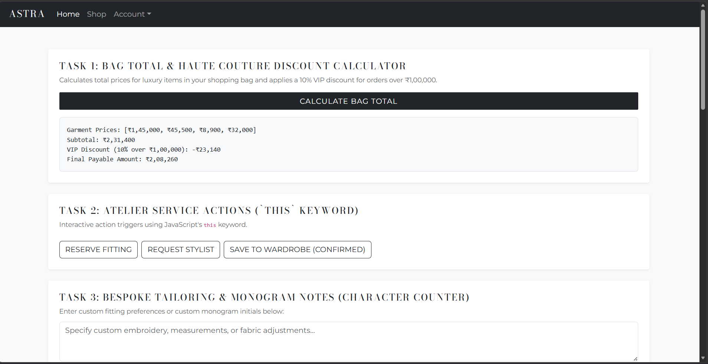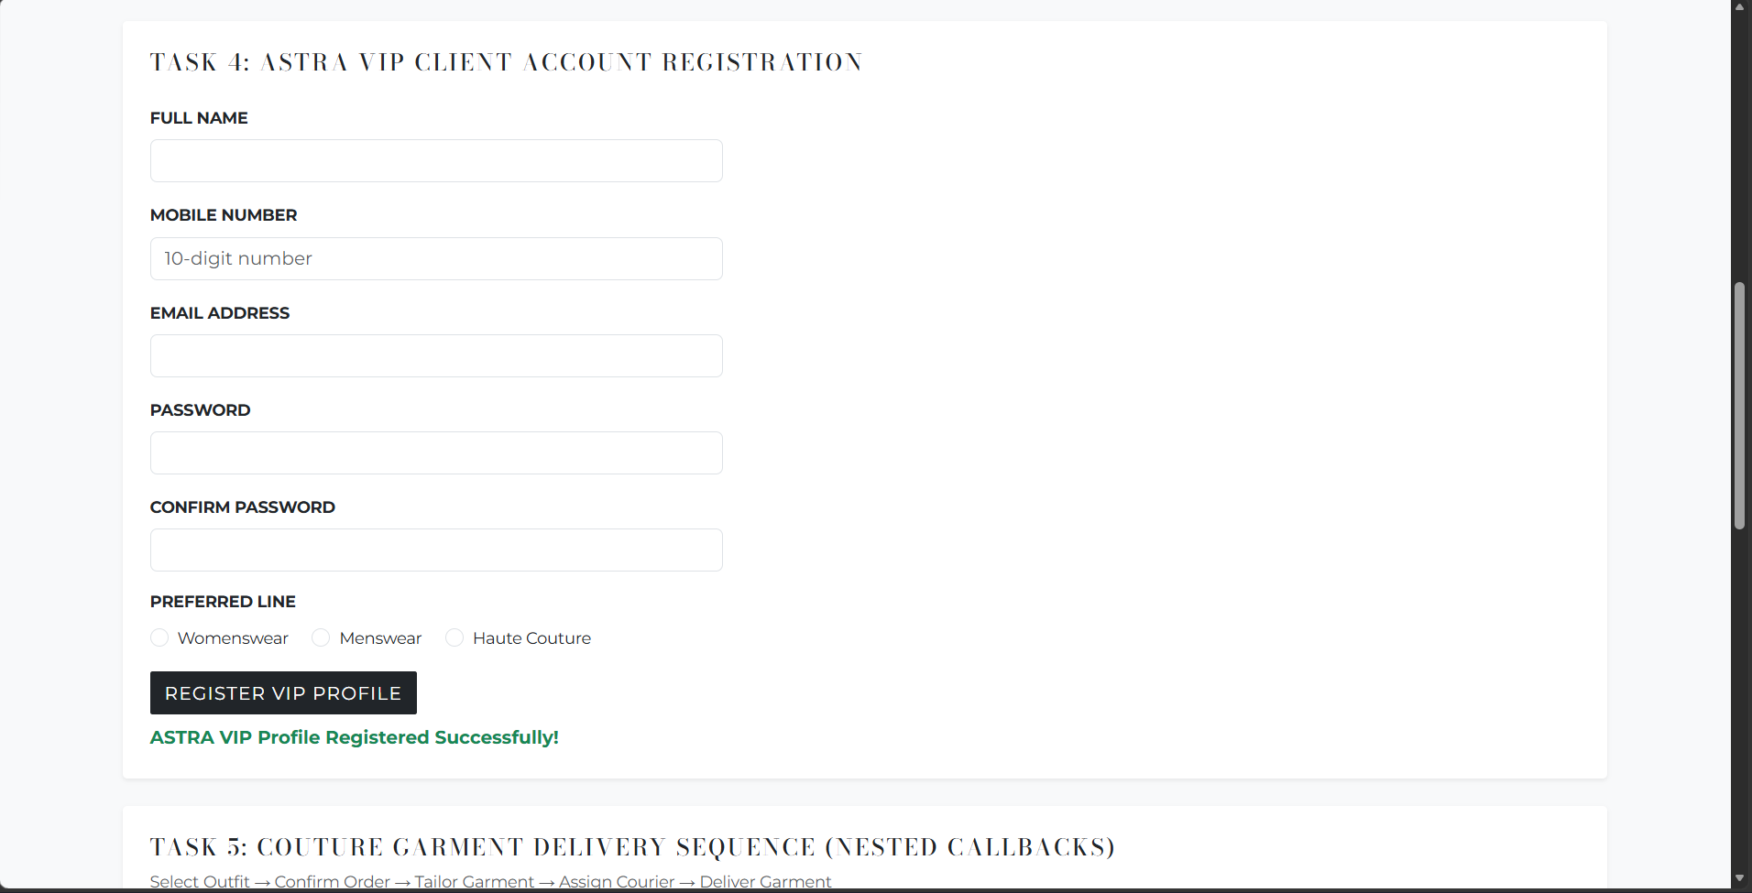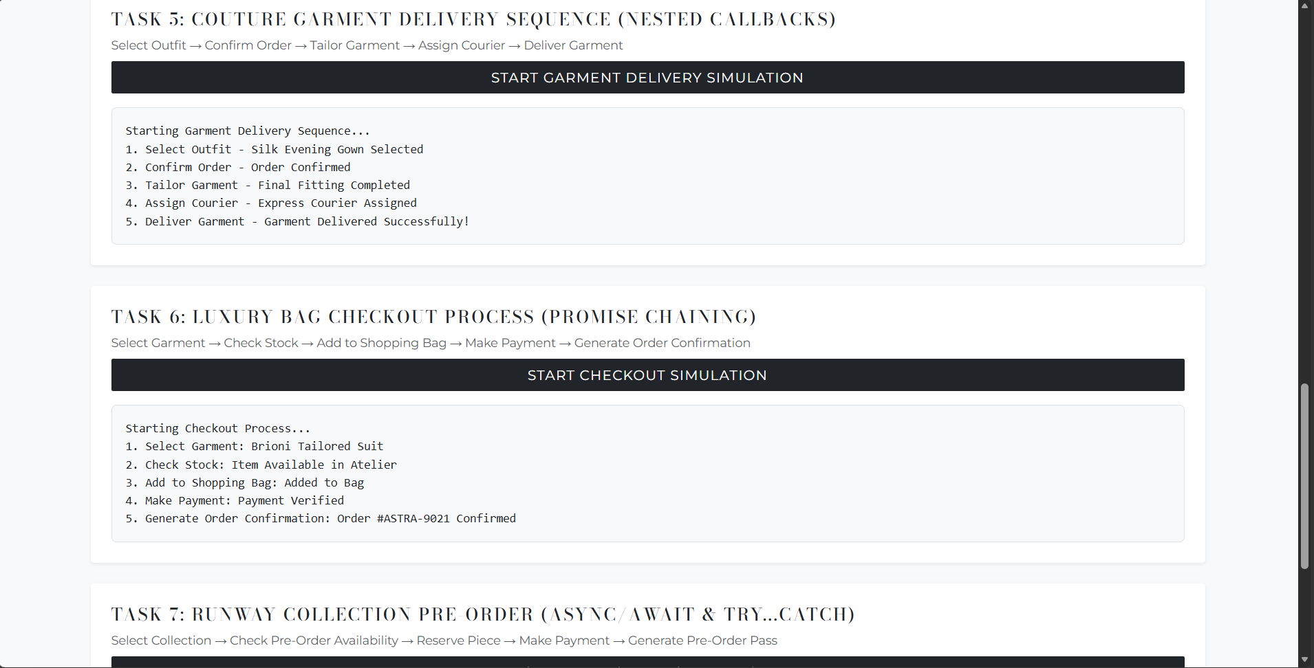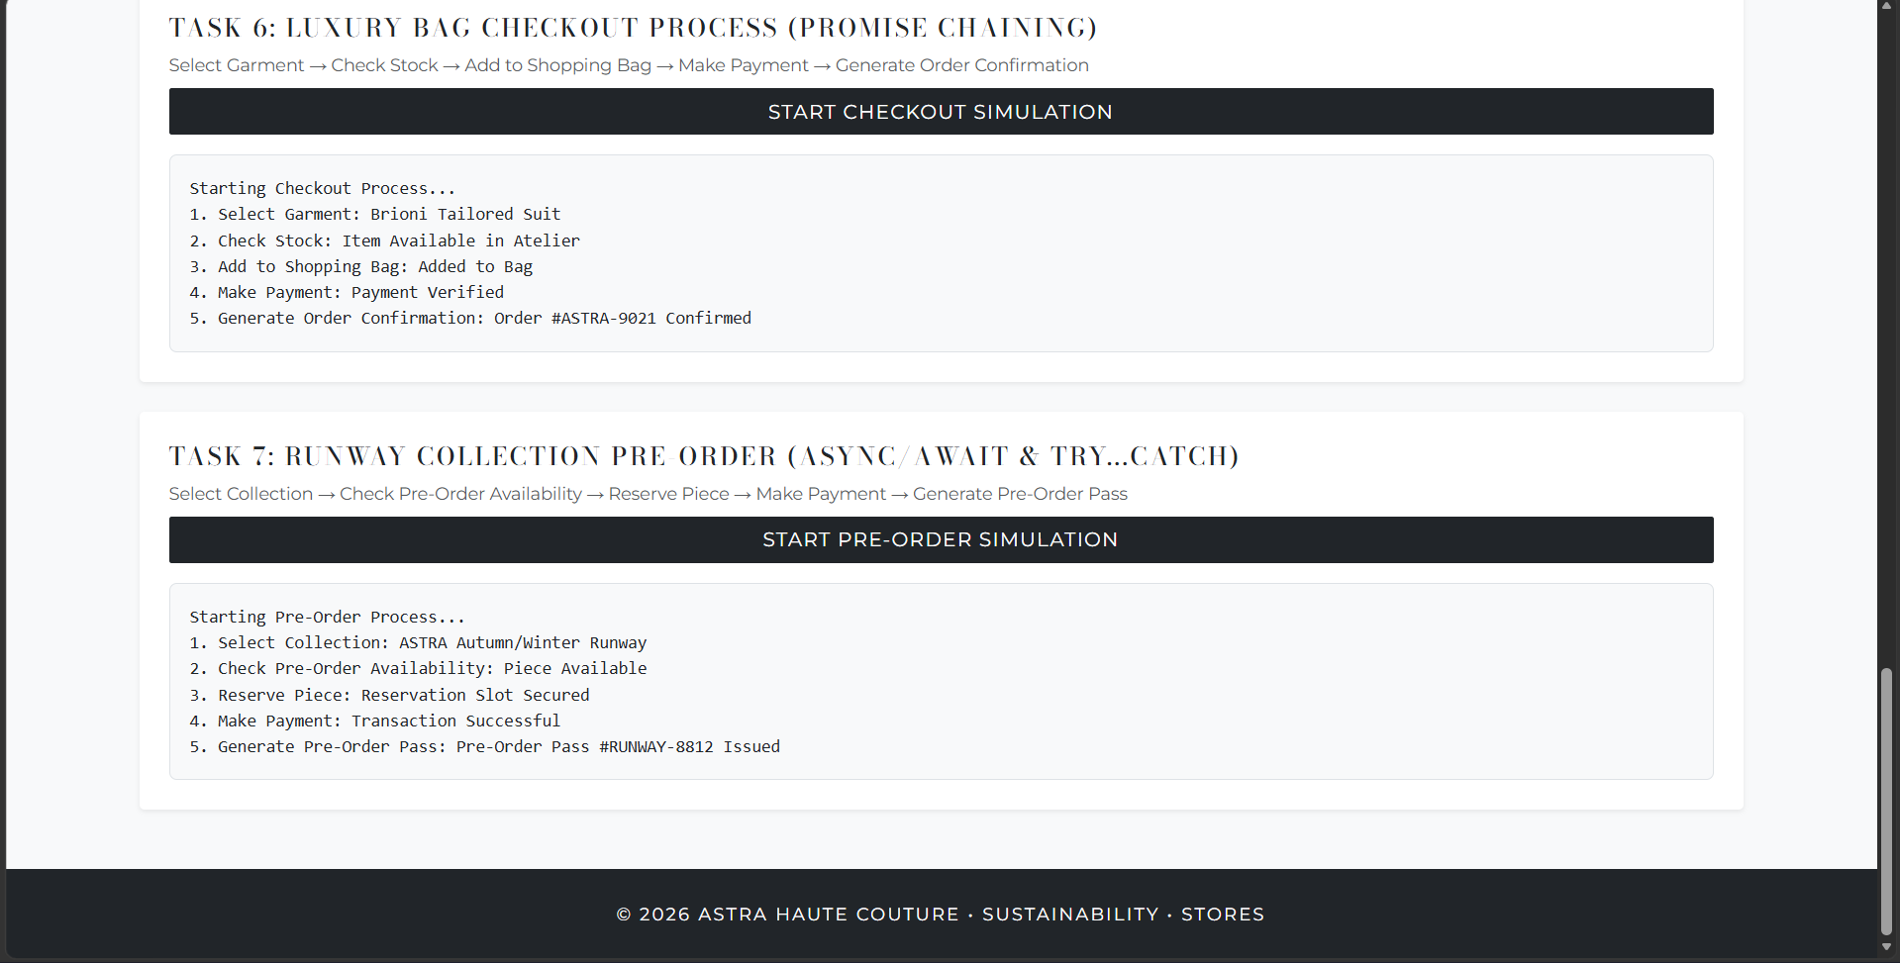

Link of the Generated website
ASTRA | Haute Couture Laboratory Tasks

Post Lab Subjective/Objective type Questions:
- What is the use of containers in bootstrap? Explain in detail.
Ans Bootstrap Containers Wraps, centers, and pads page content to align layouts across screen sizes.
- .container: Responsive fixed-width (adjusts per breakpoint).
- .container-fluid: Full-width (100% width across all screens).

- Name the classes to achieve the different button styles in bootstrap.
Ans Button Classes Requires the base class .btn paired with style and size modifiers:
- Solid Styles: .btn-primary, .btn-success, .btn-danger, .btn-dark
- Outline Styles: .btn-outline-primary, .btn-outline-dark
- Sizes: .btn-sm, .btn-lg

- Write details about the Bootstrap Grid system.
Ans A mobile-first, flexbox layout based on a 12-column grid:
- Hierarchy: Container $→$ Row (.row) $→$ Columns (.col-*).
- 12-Column Rule: Column values in a single row must total 12 (e.g., .col-8 + .col-4).
- Key Breakpoints: .col- (mobile), .col-md- (tablet), .col-lg- (desktop).

Conclusion:
A responsive fashion web application was successfully developed using HTML5, Bootstrap 5, and JavaScript. The project effectively demonstrated core front-end development concepts, including Bootstrap layout system utilization, client-side form validation, dynamic DOM manipulation, and modern asynchronous JavaScript execution patterns (Callbacks, Promises, and Async/Await).

Signature of faculty in-charge with Date:

